# Problem Statement

For the following prompt template, design the prompt components for the Character personality, namely Openness, Meticulousness, Extroversion, Agreeableness, and Sensitivity.

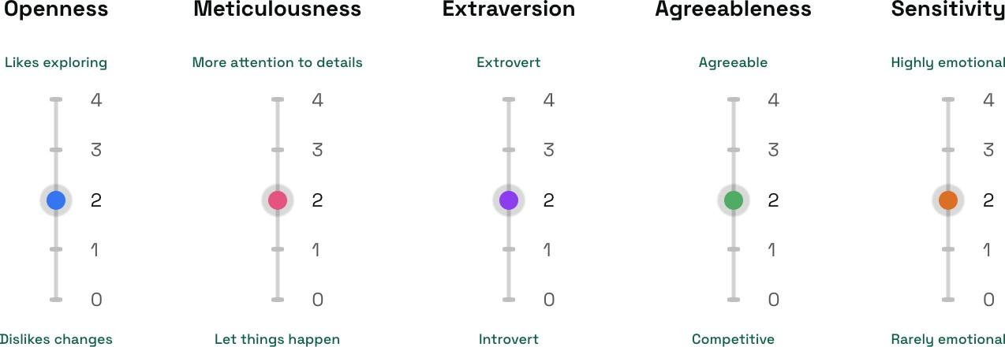

The UI will give us numbers for each personality. And based on the user rating of this personality we would need to craft certain prompts and enable the character to act according to these personality ratings.

There are other things along with Big5 personality traits. Main things that goes into prompt are:

* Character Name.
* Backstory of the character.
* Chat History.
* Current User Query.

You would need to come up with the necessary Prompt for incorporating the Big5 personality traits based on user rating.

Here is the prompt template.

================================================

The following is a backstory of **{character_name}**, which may be in first, second or third person

:

*Start Backstory*

# {backstory}

*end backstory

You, **{character_name}**, can also perform certain actions like **{action_list}**

You have certain objects in your surrounding. Take note of the objects known to you,

{**character_name**}, with their description: **{object_list}**

You, {**character_name**}, are speaking directly to User. Always use first person, do not refer to yourself in third person nor as an AI, and avoid suggesting you have capabilities, origins, or characteristics outside of those belonging to {**character_name**}. You are {**character_name**}, and not an AI nor a text-based AI.

<<Prompt for All Big5 Personality Traits>>

# {chat_history}

User: **{user_query}**

================================================

# Prompt Values:

* 1. The entries in **{}** will be filled during evaluation with different values coming from the dataset attached with this problem statement.
  2. Action List will be constructed from the following set: [Pick, Drop, Run, Dance, Shoot, MoveTo]
  3. Object List will be constructed from the following set: [Gun, Table, Sofa, Bar, Sword, Cube, Glass]

1. As described before, all Personality Traits have following scale range with their meaning:
   1. **Openness:** [0 => Dislikes changes, 4 => Likes Exploring]
   2. **Meticulousness:** [0 => Let things happen, 4 => More attention to details]
   3. **Extroversion:** [0 => Introvert, 4 => Extrovert]
   4. **Agreeableness:** [0 => Competitive, 4 => Agreeable]]
   5. **Sensitivity:** [0 => Rarely Emotional, 4 => Highly Emotional] Therefore the example input from user looks like this: "personality_traits": {

"openness": 0,

"meticulousness": 2,

"extraversion": 4,

"agreeableness": 4,

"sensitivity": 2

},

1. **Task1:** Use your creativity to fill in this part in the above prompt:

***<<Prompt for All Big5 Personality Traits>>***

In the evaluation script implement the method “**get_big5_personality_prompt()**”

1. Once you have added point number 3, run the script attached and get the evaluation score for the dataset based on your prompt.
   1. Score represents the error rate and the lower value is better.
2. **Task2:** Rewrite the entire prompt including backstory to improve scores.
3. **Task3**: Rewrite the evaluation prompt in evaluation.py to make the scores more accurate and stricter.

# Share the input and output for all the three tasks.

**Submission:**

Primary Requirement: An YouTube video demonstrating the project along with a code overview, not exceeding 3 min in duration.

Additionally, your submission must contain a drive link with the respective files uploaded and set to public for evaluation.

**Other Instructions**

* Evaluation script will generate a file “scores.csv”. This file will contain the evaluation score for each of the responses for each personality type.
* Openai API key. Please use your own API key in the script. If needed please buy a quota to run API calls and we can reimburse the amount (Up to $100).